Office of Human Resources, Employee Benefits, IH 209 541-962-3087

Sample Earnings Statement
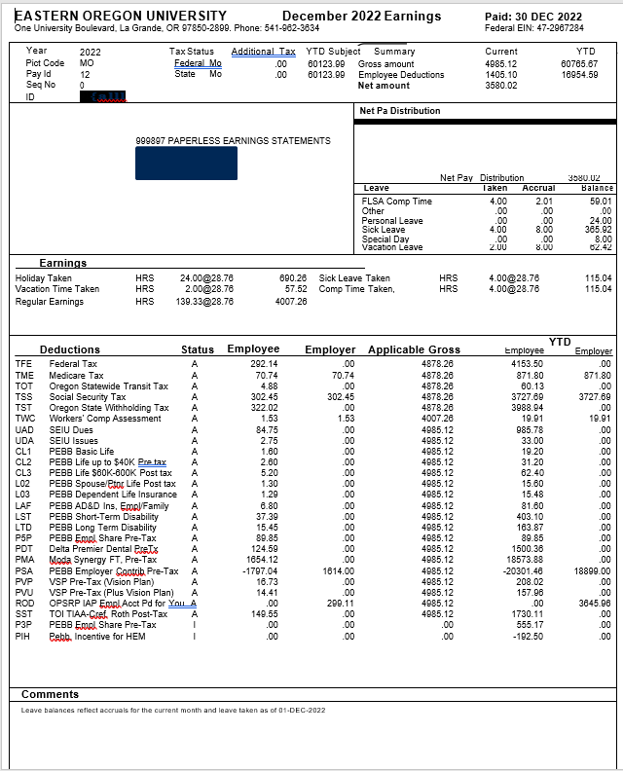

This section identifies the pay period (month and year), employee ID, tax status from the
employee’s W-4, and year-to-date subject tax. It also displays additional tax withholdings, if any.

This section identifies the employee with their check delivery department code and mailing address.

The Earnings section identifies earnings for the pay period.

The Deductions section identifies deductions from the earnings; employer contributions for health and pension programs; applicable gross; and year-to-date amounts.

Additional comments are located at the bottom of the statement.
This section summarizes the gross earnings, deductions, and net pay for the current month and year to date.

The Net Pay Distribution section indicates the net pay distributed by direct deposit account number and amount.

The Leave section displays leave taken on the last timesheet submitted, leave accrual for the current pay period month, and balances. Balances do not reflect leave taken that has not yet been submitted by the timesheet.

Deductions Section:
Deductions and/or credits in the column titled “Employee” are used to calculate the net pay of the employee. The “Employer” column reflects charges to the department, such as pension contributions paid by the University for the employee or other payroll expenses, such as department aggregate charges for benefits.

Both mandatory and voluntary deductions may be withheld from an employee’s paycheck. Mandatory deductions are required by law and
include State and Federal income tax, Social Security and Medicare, and Workers’ Compensation Insurance. The 5% or 3% employee premium share amount for the CORE benefit package (Medical, vision, dental, and employee basic life insurance) is also deducted from an employee’s paycheck. Voluntary deductions include benefits package deductions (i.e., optional employee life insurance, short-term disability, FSA contributions, etc.), voluntary retirement savings – TDI program, and other deductions authorized by the employee (i.e., Charitable Fund Drive, parking permits, etc.).

Office of Human Resources, Employee Benefits, IH 209 541-962-3087

Employee CORE Health Insurance Benefits

A benefit eligible position is one that is at least .50 FTE and is at least 90 days in length and qualified under PEBB rules. The employer contribution towards the CORE benefit package for full-time classified employees is between 95% and 97%. Part-time classified employees receive a pro-rated employer contribution towards their benefit package. The CORE benefit package includes the following plans/deductions codes:

Benefit | Deduction Code*
Employee basic life insurance | CL1
Dental Insurance | PD*
Medical insurance | PM*
VSP Basic Vision (Full time Kaiser medical enrollment excluded from coverage) | PVP
PEBB Employee Share Pre-tax** | P5P or P3P
Employer Contribution*** | PSA
PEBB, HEM Incentive**** | PIH
VSP Plus Plan Pre-tax (Full time Kaiser medical enrollment excluded from coverage) | PVU (not a core enrollment)
Benefit subsidy for part-time classified employees enrolled in a part-time plan | PST
Opt-out in place of medical insurance or medical | POO A
$40 Premium Subsidy. If monthly salary base is less than or equal to $3,279 (effective 07/01/22). Salary base rate is the full-time equivalent rate. Must be enrolled in a full-time medical plan. | P40

*Deduction Code is a three digit code identifying the deduction/plan. Dental plans start with “PD” and medical plans start with “PM”
** PEBB Employee Share Pre-tax, this is the employee’s share of CORE premium costs minus any subsidies. Part time employee’s amount it is prorated based on the number of hours worked/paid in the pay period.
***Employer Contribution: This shows as a negative figure. For full-time classified and .5+FTE unclassified employees, this amount shows at 100% of premium costs for CORE benefits. The employee cost is calculated and shown under the Employee Premium Share deduction code (P5P or P3P). For part-time classified employees, the employer contribution is prorated based on the number of hours worked/paid in the pay period.
****PEBB, Incentive for HEM: If you are eligible and participate in the HEM program, you will receive a monthly cash back incentive of $17.50. This shows up as a negative deduction, thus reducing your cost.

Part-time classified employees may have additional out of pocket cost for CORE benefits (greater than 5%) based on the prorated employer contribution and the plan/tier they are enrolled in. To determine the total employee cost, add the amounts listed under the above codes together.

If you cover a domestic partner on your CORE benefits package and are required to pay the imputed tax value for that coverage, this will appear on your earnings statement in the earnings section as additional taxable income.

Employees may also sign up for additional optional benefits through PEBB, such as employee, spouse or dependent life insurance (deduction codes “CL2”, “CL3”, “L02”, and “L03”), accidental death & dismemberment insurance (“LAE” or “LAF”), disability insurance (“LST”, “LTD”), long term care insurance (“LCE” and “LCS”), and flexible spending accounts (“PXM” and “PXS”). These are not included in the CORE benefits package and are deducted from the employee’s pay.

On the sample earnings statement, the employee is a full-time unclassified employee who has chosen the PEBB Moda Plan for medical coverage and Delta/Moda Traditional for dental coverage. To determine the employee’s cost of the CORE benefits package, add the following benefit codes together:

Deduction Code | Description | Employee | Employer
CL1 | PEBB Basic Life $5,000 | 1.60 | 0.00
P5P | PEBB Empl Prcnt, Pre-Tax | 89.85 | 0.00
PDT | Delta/Moda Traditional Pre-Tax | 124.59 | 0.00
PMA | Moda, Pre-Tax | 1654.12 | 0.00
PSA | PEBB Employer Contribution | --1797.04 | 1,383.00
PVP | VSP Pre-Tax (Vision Plan) | 16.73 | 0.00
TOTAL cost to employee for CORE Benefits Package |  | 89.85 | 1,383.00
PIH | Pebb, Incentive for HEM | -17.50
Cost after HEM Incentive (if applicable) |  | 72.35

Office of Human Resources, Employee Benefits, IH 209 541-962-3087

PEBB Health Engagement Model (HEM) Incentive and Cost Containment Surcharges

PEBB has three health care and cost containment programs for the 2023 plan year. If you enroll in a medical plan, your participation status in each of these programs will determine if there is any additional cost and/or cashback incentive.
- Health Engagement Model (HEM): Available only to employees with active coverage as of September 2022. Participating employees will receive a monthly cashback incentive. This incentive shows as a “negative” deduction, which results in cashback to the employee.
- Tobacco Use: A surcharge is assessed based on your and your enrolled spouse/domestic partner’s tobacco use.
- Spouse/Domestic Partner Other Non-PEBB Employer Coverage: A surcharge is assessed if your enrolled spouse/domestic partner has other employer group coverage available and does not enroll in that coverage.

Deduction Code | Description | Amount
PIH | PEBB, Incentive for HEM | -17.50 employee
PTS | PEBB Tobacco Surcharge Pre-Tax | 25.00 employee or spouse/domestic partner only  50.00 employee + spouse/domestic partner
POS | PEBB Other Cvg Surchg Pre-Tax | 50.00

Pension & Voluntary Retirement Deductions
Employees may be eligible for pension contributions, paid for by EOU, if they meet the pension eligibility requirements. For additional information on eligibility, please visit the EOU website at https://www.eou.edu/hr/retirement/. Eligible classified employees are automatically enrolled in Public Employees Retirement System (PERS)/Oregon Public Service Retirement Plan (OPSRP). Unclassified employees are given a one-time irrevocable choice between PERS/OPSRP and the Optional Retirement Plan (ORP). Eligible employees receive an employee contribution, paid for by EOU which appears in the deductions section under the “Employer” column (as they are funded by the employer and are not a deduction from your pay). The PERS/OPSRP deduction codes start with “R0” for PERS/OPSRP members and the ORP deduction codes begin with “R1” through “R3” for ORP members. EOU also pays an Employer a contribution, which does not appear on your statement. The Employer portion is used in the PERS/OPSRP system to fund the pension benefit for retiring employees. In the ORP program, the Employer contribution is reflected on the
employee’s ORP statement. The Employer contribution is subject to vesting rules for both the ORP and PERS/OPSRP programs.

Employees may also enroll in additional voluntary retirement savings through either the Tax-Deferred Investment 403(b) Plan or the Oregon Savings Growth (457) plan. These deductions will appear with deduction codes beginning with “S”.

Workers’ Compensation
Workers’ compensation insurance provides benefits for workers who are injured as a result of work. Employees are required to pay an assessment by payroll deduction for each full or partial hour of work. The basis for determining the assessment is the number of hours worked. This deduction is shown on your earnings statement as deduction code “TWC”.

State & Federal Income Tax Withholding
Deductions are determined by filing status provided by the employee on their W-4. If no W-4 is filed, employee’s withholding is based on a default of single status with zero dependents. Withholding is determined by formulas provided by Federal and State governments.

Social Security & Medicare Tax
Deductions for Social Security and Medicare tax are based on certain percentage rates set by the Federal government. Yearly maximums are set for Social Security subject wages. Once the maximum amount has been withheld, no further deduction is taken until the following January. The percentage of Social Security and Medicare tax may differ from year to year. Both the rate sheet and the maximum amounts are available on the online Fact Sheet available at the Social Security website at www.SSA.gov.

