How to Check Student Employee’s Leave Balances
Go to Mountie Hub and click on Employee Services
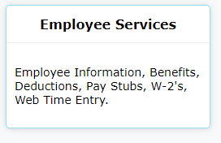

After Employee Services, click on Employee Information
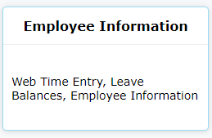
After Employee Information, click on My Team
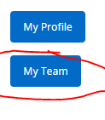
After My Team, click on the student whose leave balances you would like to view. The leave balances will be visible on the right side of the page.

