How to Check Leave Balances in Mountie Hub

Log in to Mountie Hub and click on Employee Services
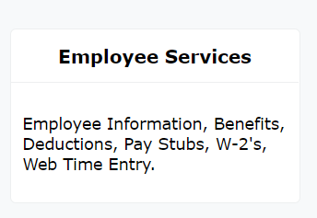

After Employee Services, click on Employee Information
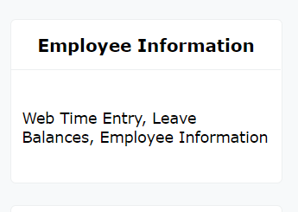

After Employee Information, locate the Leave Balances as of [date].
Leave hours can be found here in the boxes below the above heading. If you are not seeing all leave balances, click on Full Leave Balance Information.
