FOIDOCH -- Document History
To view status of Purchase Order, Invoice or Check or to review a document after it has been paid and/or has gone through the final completion process.
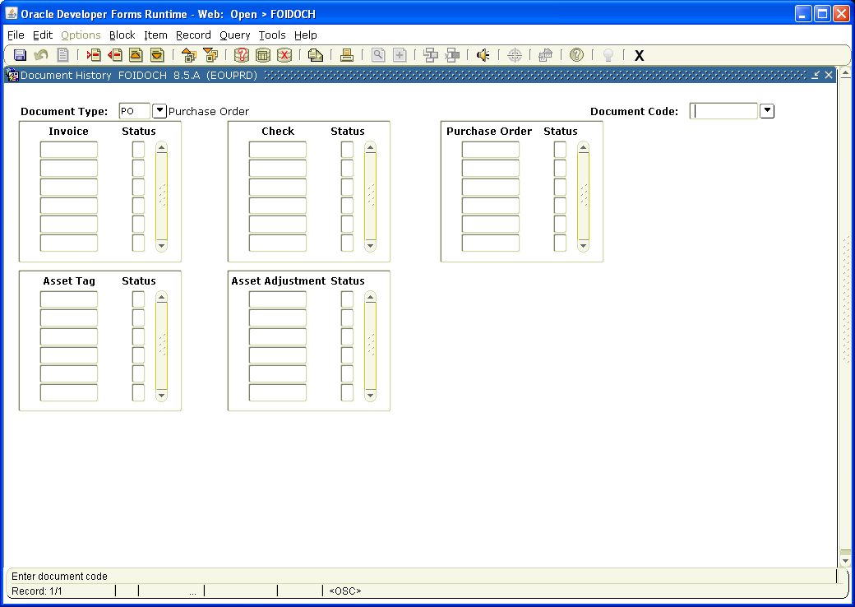
Type Document, PO or Check Number
Choose PO, INV, or CHK

Type Document Type in the Document Type box. i.e. PO for Purchase Order, INV for Invoice or CHK for Check.
Tab to Document Code:

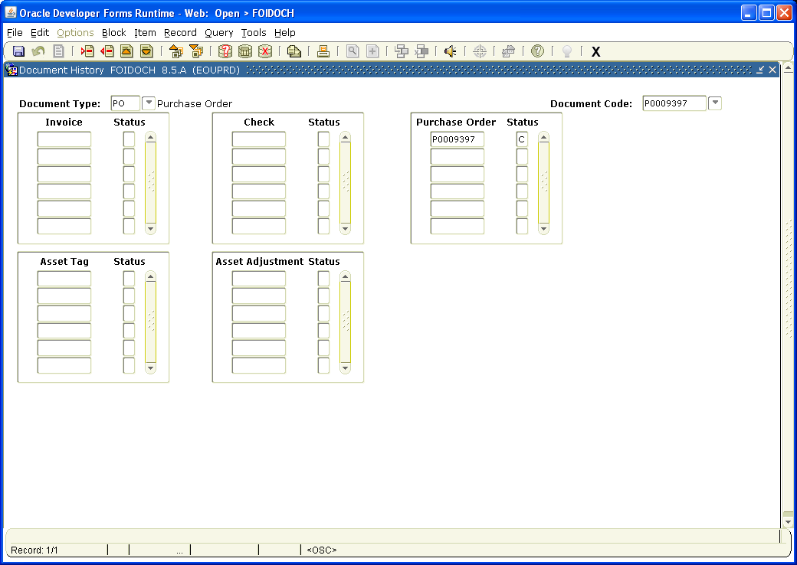

Type the PO number, Invoice number or Check number in the Document Code box.
Page Down to view document status – C = completed, A = approved, O = open, P = paid. For definition of other Status Indicators, click on Options on the tool bar and select View Status Indicators.
Once PO is marked A, you can exit out of this screen by clicking on the X on the tool bar and going to FWAPORD to print it out.
If there is an O in the status box, it means someone has disapproved the document. If a document is disapproved, you will receive a Banner Message (under My Links) and will need to follow the instructions in the message to recomplete the document. It will need to go back through the approval process before you can print it out.

