FGAJVCD -- To bill another campus department for goods and/or services.

Go To… FGAJVCD (enter)

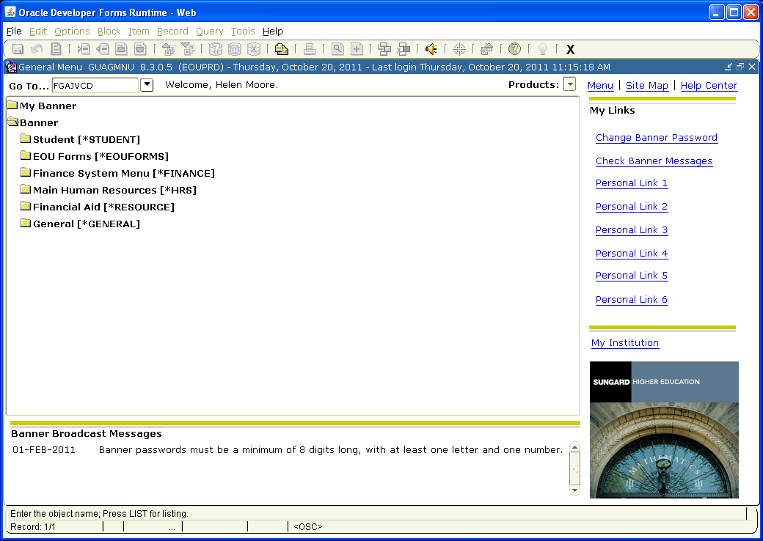

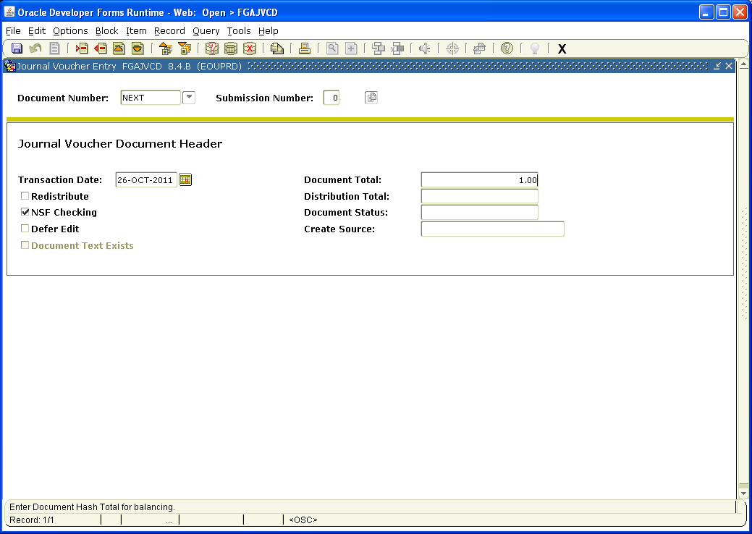
Backdate if necessary

Type NEXT in the Document Number: field and then (Page Down). Today’s date will default into the Transaction Date: field. Change it only if you are backdating the document. (Tab) to Document Total and enter the total dollar amount of all entries; debits and credits.

Click on Options on the toolbar, then Document Text [FOATEXT].

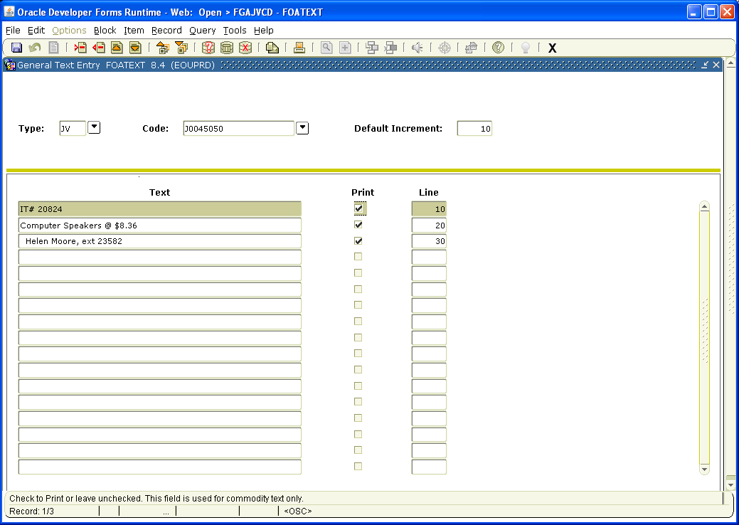

Click on the top blank line under Text and enter information about the transaction you are processing.
Be concise, but enter enough that the department you are billing can understand what the charges are for.

The last line of text should include your name and phone extension.

Put a checkmark (for each line of text) in the boxes under Print by clicking in each box. If there is no checkmark in the box, the corresponding line of text will not print.

Make a note of the JV number (Code), in case you need to reference it later.

Click on the Save button, then the X button on the Toolbar to save and exit FOATEXT.

Page Down

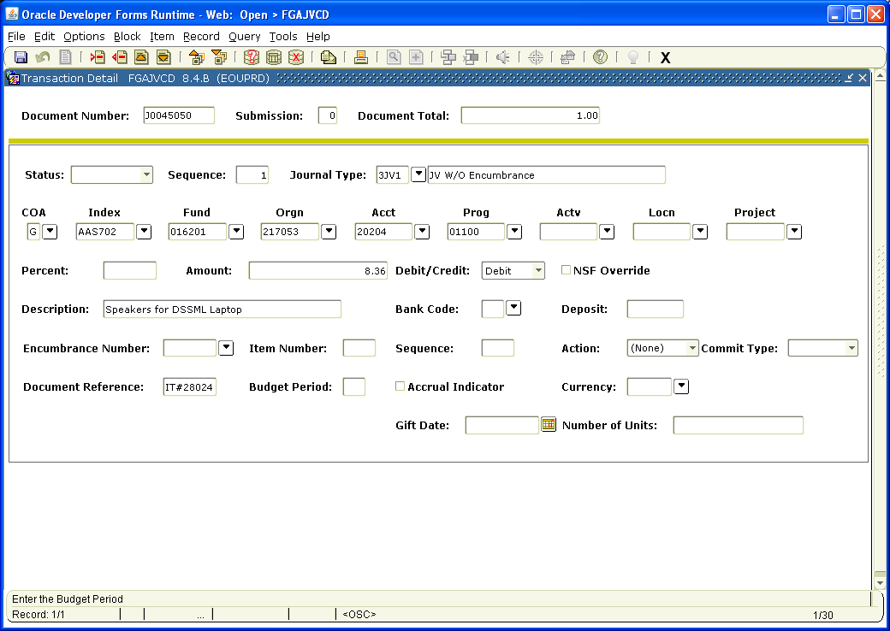

Note: Each regular Journal Voucher must have at least two accounting records, one Debit and one Credit. The Amount of the Debit(s) must equal the Credit(s).

Tab once to Journal Type and enter 3JV1.

Tab again and G will default into the COA (Chart of Accounts) field.

Continue tabbing to fill in the Index, Acct Code, Actv (if applicable), and Amount you wish to charge. Tab to Debit/Credit and click on the down arrow. Choose Debit.

Tab to Description and enter a brief description of the charge. This is what will appear on the budget documents, so be as specific as possible in the small space allowed.

Tab to Document Reference and enter the reference document, such as Purchase Order # or Invoice #.

Down Arrow to access the next record.

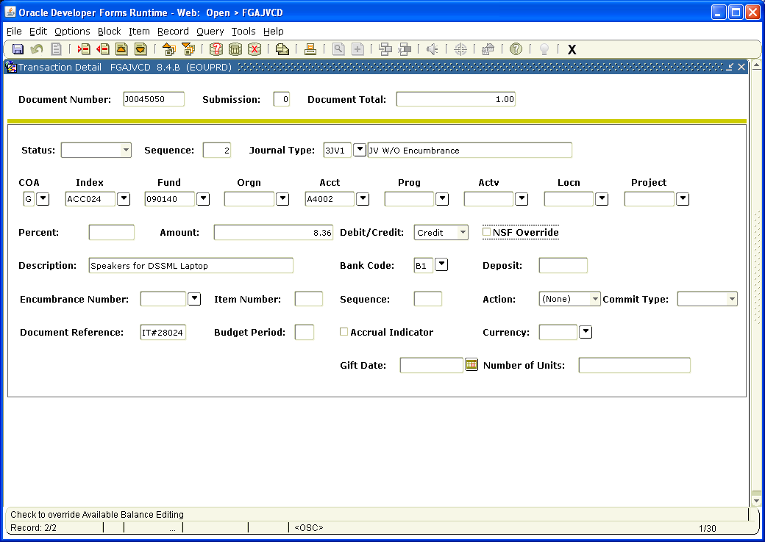

Repeat the process on Page 4 to enter the Index, Acct Code, Actv (if applicable), and Amount you wish to Credit, choosing Credit at the Debit/Credit field. Continue tabbing to enter the Description and Document Reference.

This process may be repeated until you have entered all the necessary accounting information.

Note: F4 copies the previous record. It is convienent to use this feature and just change the pertinent data. Be careful when using F4 that you do change the necessary fields otherwise, you can end up crediting and debiting the same index/account.

When you are finished, Page Down.

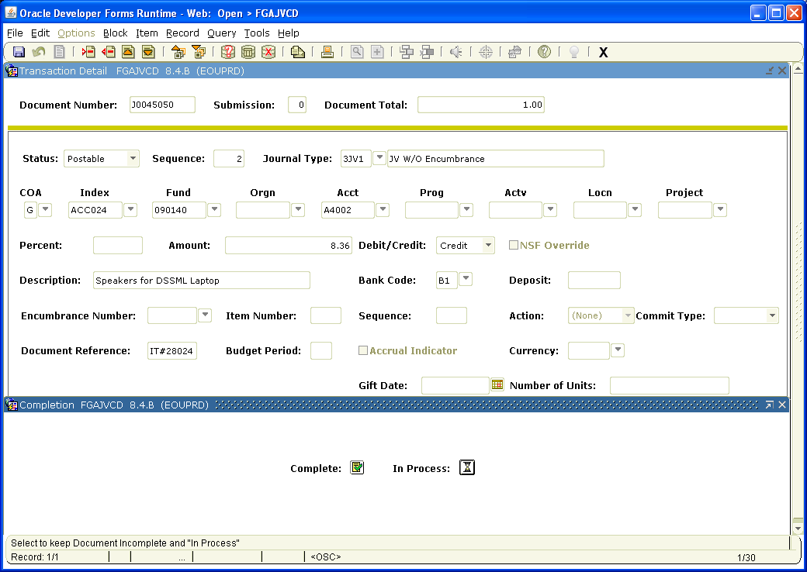

Click the box next to Complete to complete the JV or In Process to save the document so you can work on it later. Be sure to make a note of the JV number for your records.

Note: Instructions for correcting various errors are on the following pages.

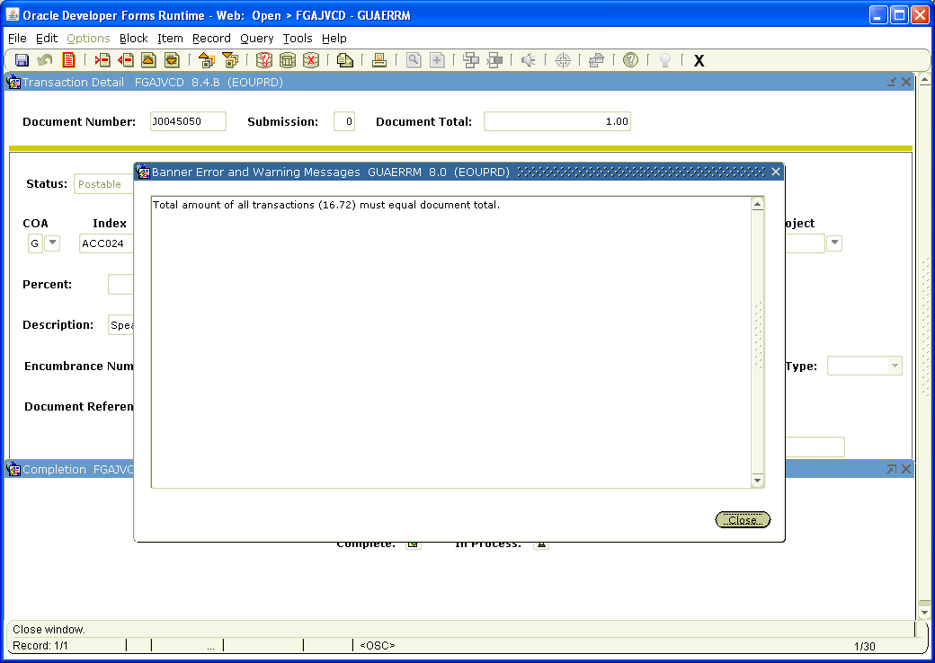

If you see this screen when you click on Complete, it means your Document Total on the opening page is incorrect.

To correct this, Close this screen, Page Up, Tab to Document Total and enter the correct amount.

Page Down twice and click on the box next to Complete.

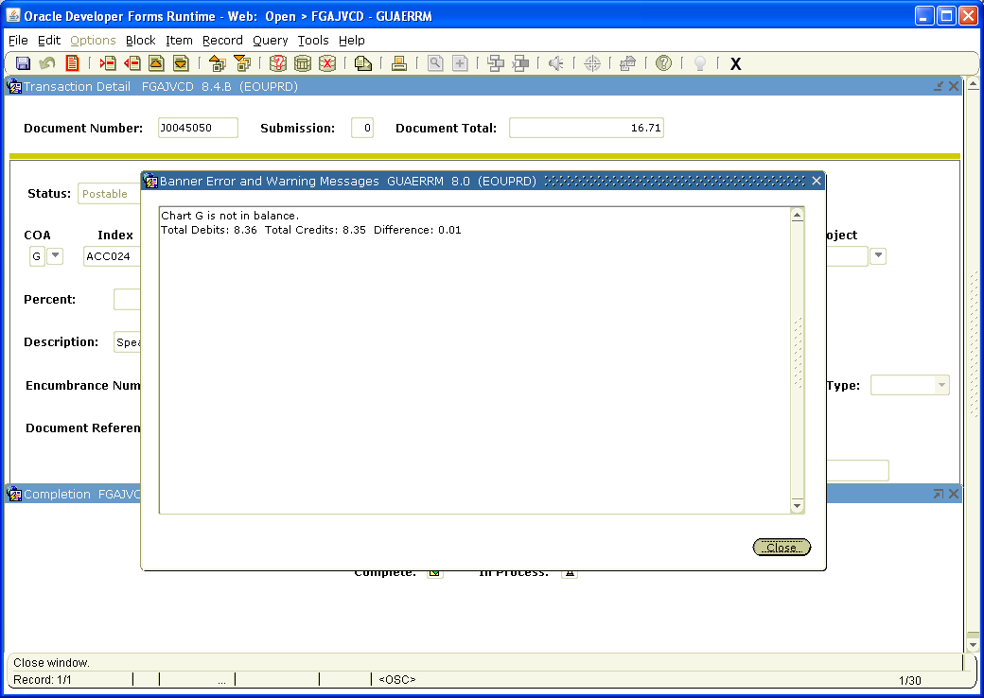

If you see this screen when you click on Complete, it means your Debits and Credits are not equal amounts (they are not in balance).

To correct this, Close this screen, identify which record is incorrect and enter the correct amount.

Page Down and click on the box next to Complete.

