FPAPURR -- Purchase Order Creation
To create a Purchase Order (PO)
Note: Purchase Orders for less than $1000 total may be ordered “confirming only” (i.e. you may place the order before the PO has been approved) as long as the vendor does not require a copy of the PO. If the Purchase Order is for $1000 or more or the vendor requires a copy of the PO to place the order, the PO must be approved in Banner before the order is placed.

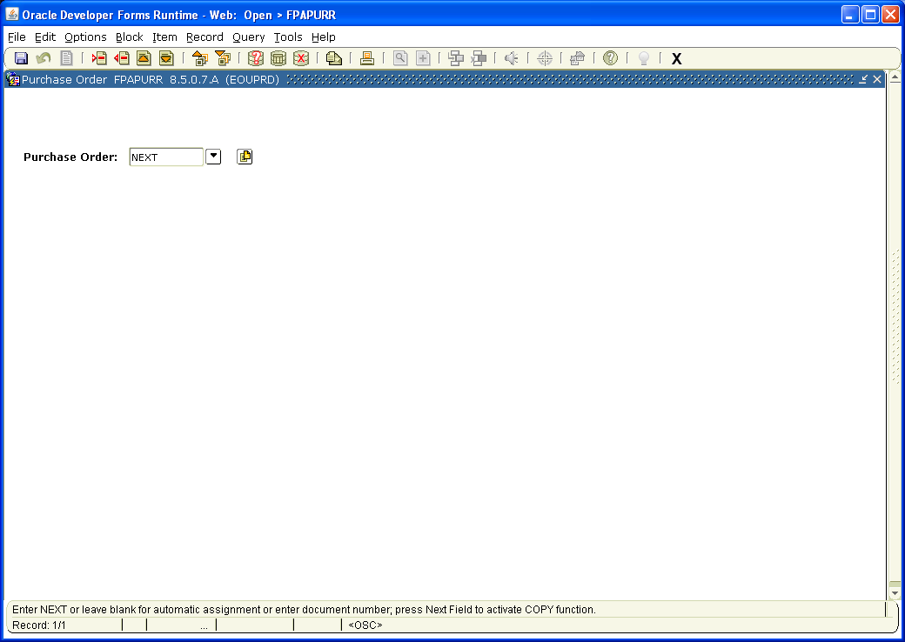
Type NEXT in the Purchase Order: field.

Page Down
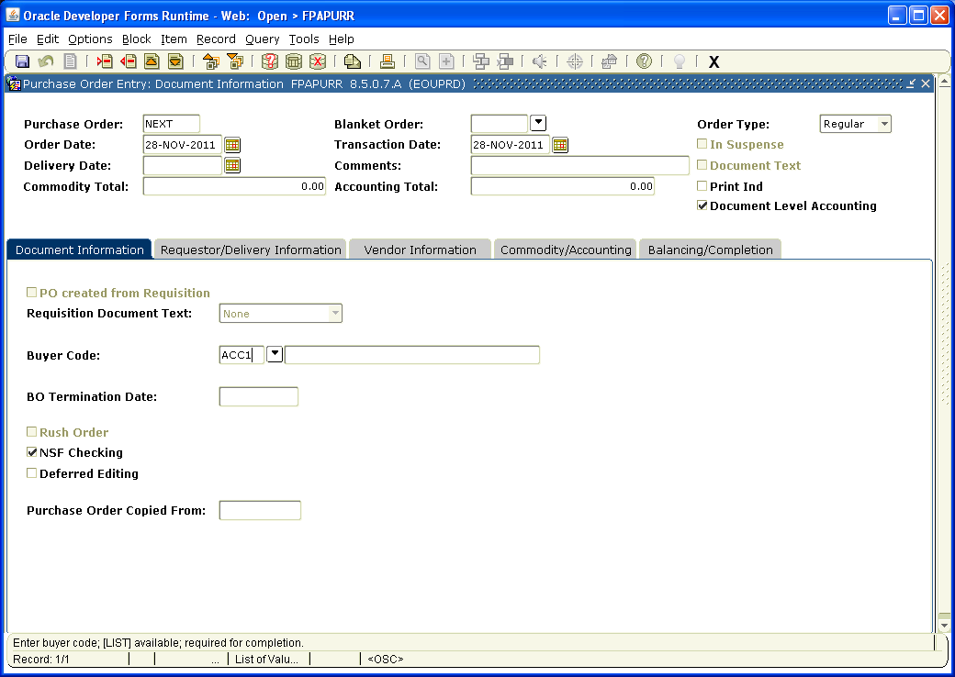
Type in your Buyer Code:
Note: The IT Department Buyer Code is ACC1

Page Down,

Page Down.

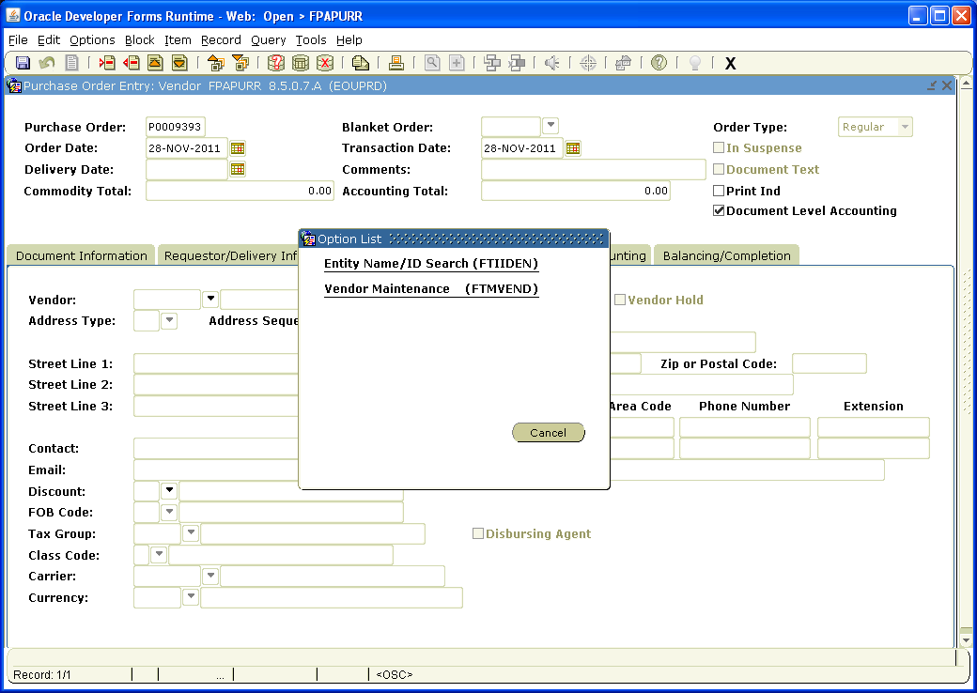

In the Vendor field, click down arrow, then click on Entity Name/ID Search

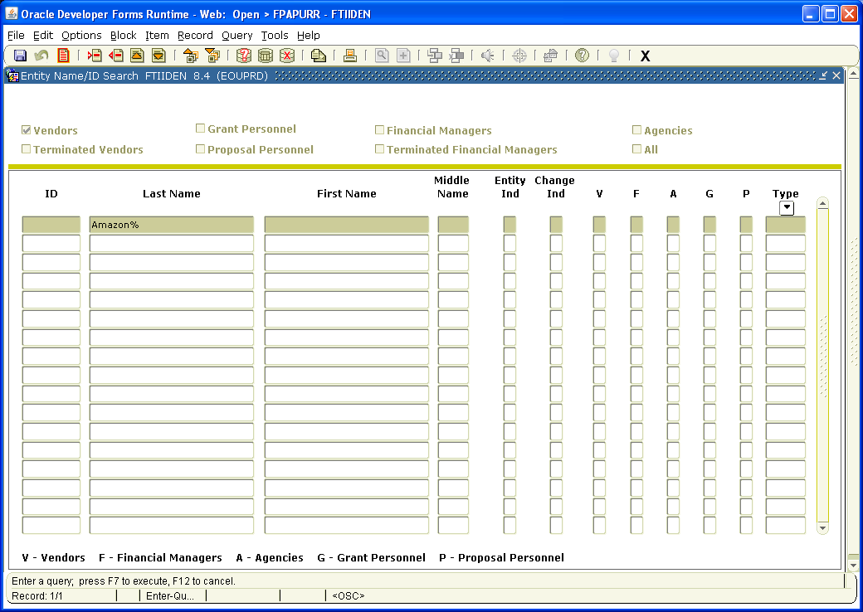

Click on ? on the toolbar to Enter Query
Type Name of the Vendor in Last Name field. Fields are Case Sensitive – use % as wild card

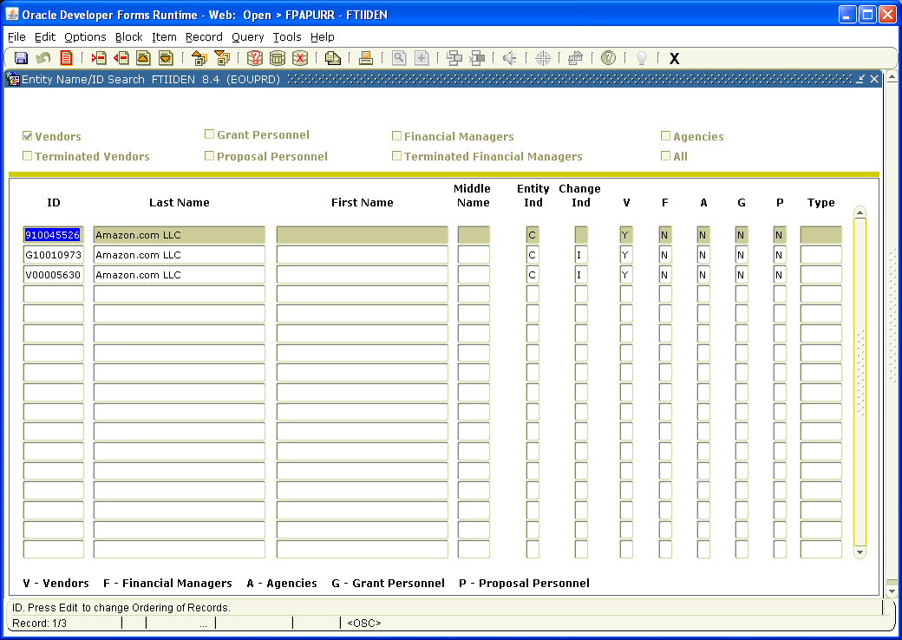

Click on button to the right of the ? on the toolbar to Execute the Query
Highlight the ID of the correct vendor and click the Select button on the toolbar (vendor number and name will automatically populate the correct fields). If you cannot locate the correct vendor, try other variations of the name, (i.e. BiMart instead of BI MART). If you still cannot locate the vendor, contact Accounts Payable Office for assistance.

Page Down

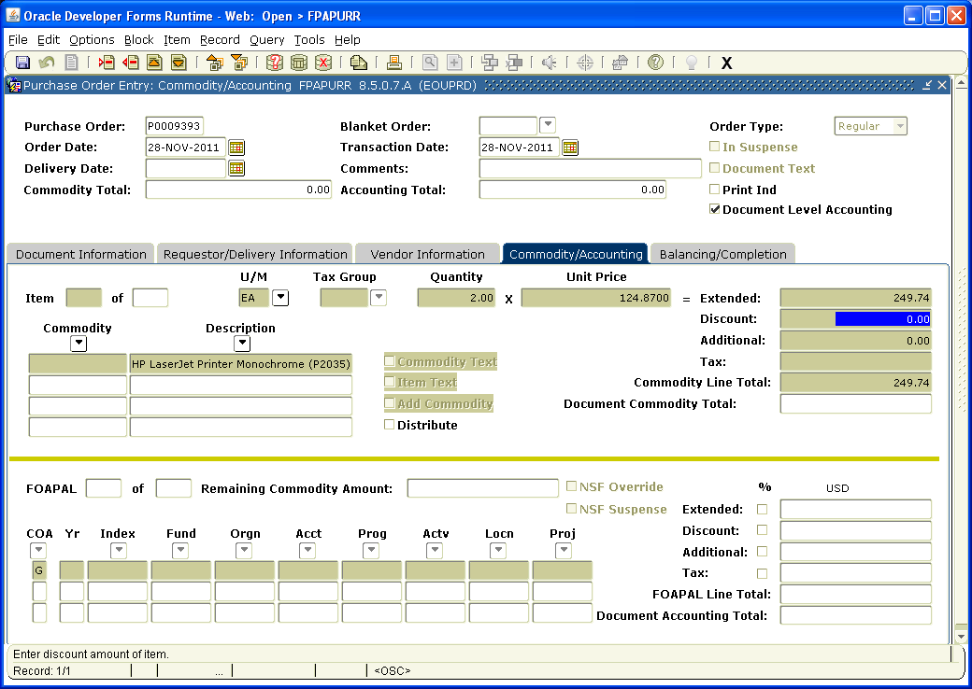

Tab to Description and enter the description of the item you wish to order. Continue tabbing and enter U/M (ea, pg, dz), Quantity and Unit Price. The Extended amount and Totals fields will populate automatically. If you have more than one item to add , arrow down to get to next record and repeat the process.

When there is more information needed for the description than there is room to type in the Description field, you can enter information in Item Text. To do this, click on Options on the Toolbar and select Item Text. Click on the top Text field and add information as needed. Arrow down to access additional text fields. Click on the Save button, then the X on the Toolbar to save and exit

Page down

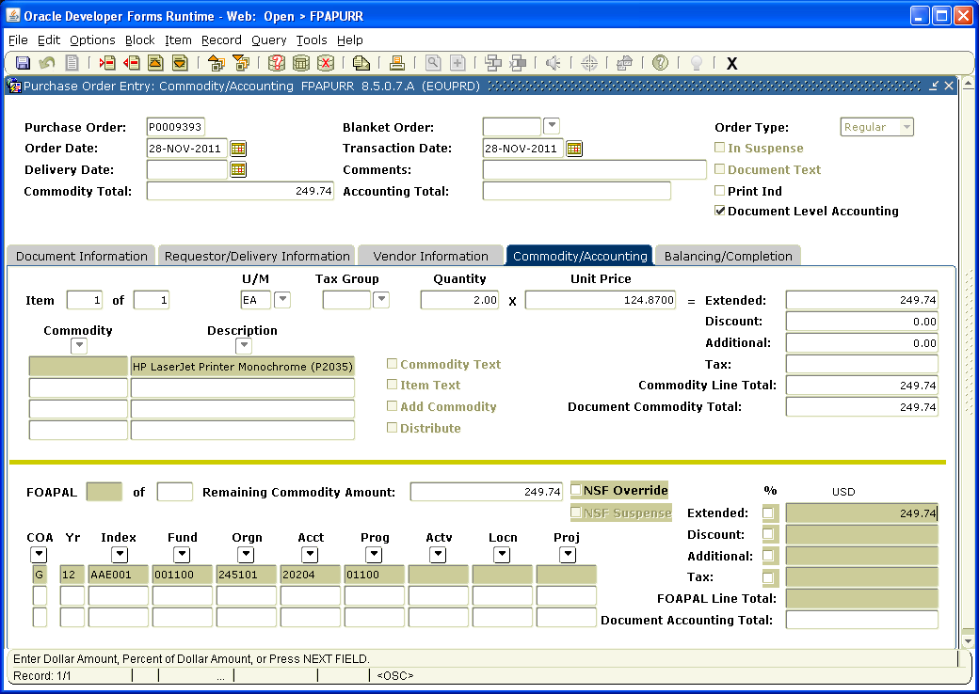

Enter Accounting Information (i.e. Index, Acct, Actv, etc). Tab to Extended and enter amount to be charged to the Index/Account. If you are charging more than one Index and/or Account, arrow down to get to next record and repeat the process.

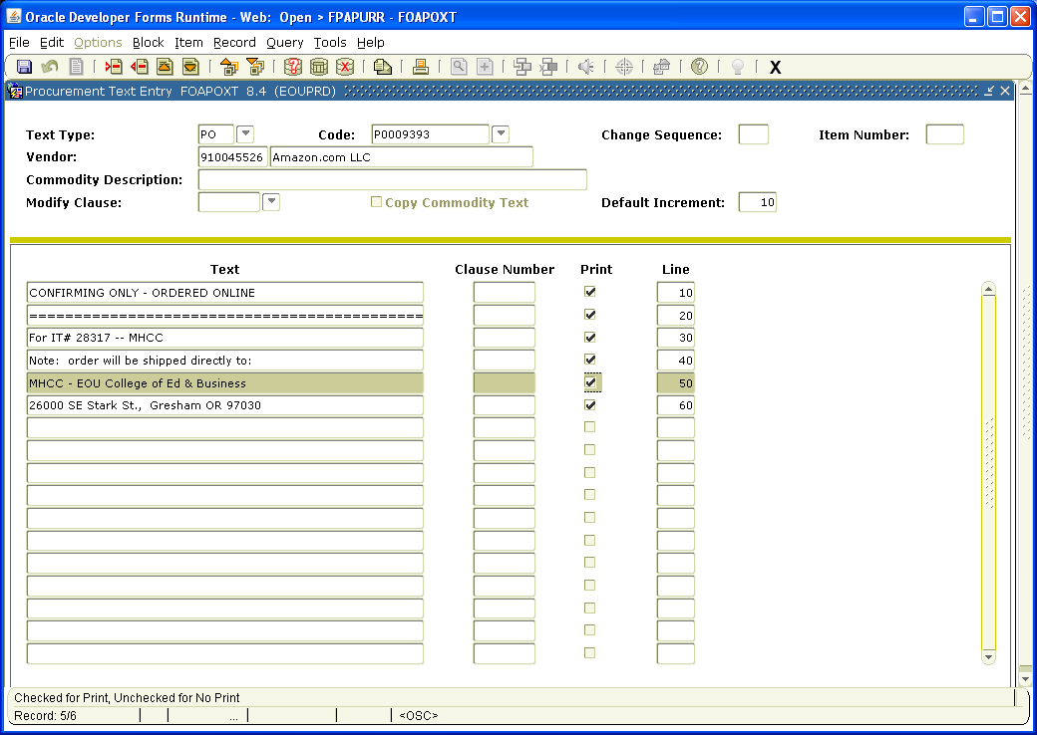
Before completing the document you will need to add information regarding how the order will be placed and who initiated the order request to the Document Text.
To do this, click on Options on the Toolbar and select Document Text. Click on the top Text field and add the required information. The first line should include how the PO will be submitted – i.e. Confirming Only – Order Placed Online, or Email Order to John@somecompany.com.
Quotes and or Contract #s should go on the next line.
On the third line, note who the order is for, i.e. For IT# 1234 – Jon Norris.
Any additional pertinent information such as special shipping instructions should be entered next.
If price quotes are required they should be entered on the next few lines. Be sure to note each company, who gave you the quote with their contact information, when they gave you the quote, the dollar amount of the quote and when the quote will expire. You will also need to uncheck the print box, because all checked lines of text will print on the PO form and quote information is confidential and should not appear on the printed PO. Once all the required information has been entered, click on the Save button, then the X on the Toolbar to save and exit.
Page down
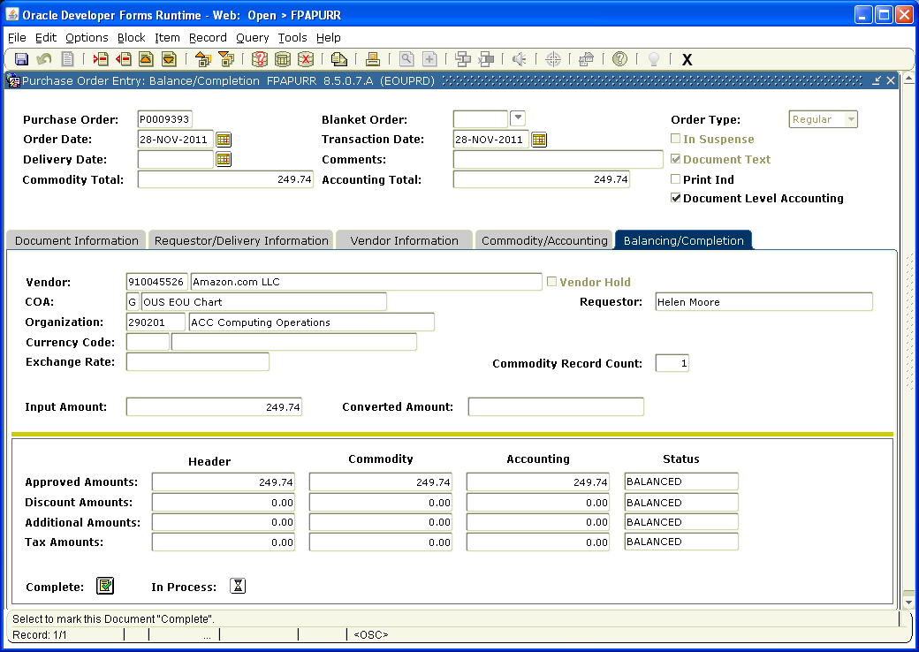

Click the box next to Complete to forward the Purchase Order to the Approval Process or In Process to save the PO so you can work on it later.

Check status of PO via FOIDOCH periodically and once it is approved print it out. If it needs to be sent to the vendor, scan, fax or mail a copy as required by vendor.

