FAAINVE -- Credit Memo
To process a Credit Memo

Process just as you would a Direct Pay invoice until you get to this screen.

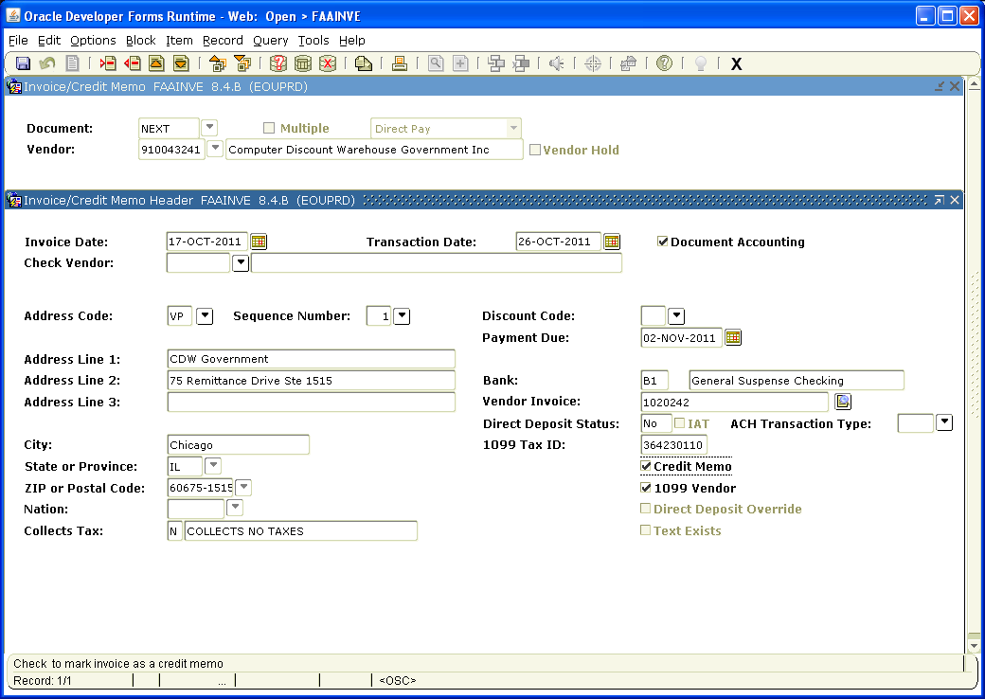

Click in the box next to Credit Memo. Note: this must be done before you page down. Once you have left this block, you CANNOT return and check the Credit Memo box. If you forget and page down without checking the Credit Memo box you will need to delete the document and start over.

Page down

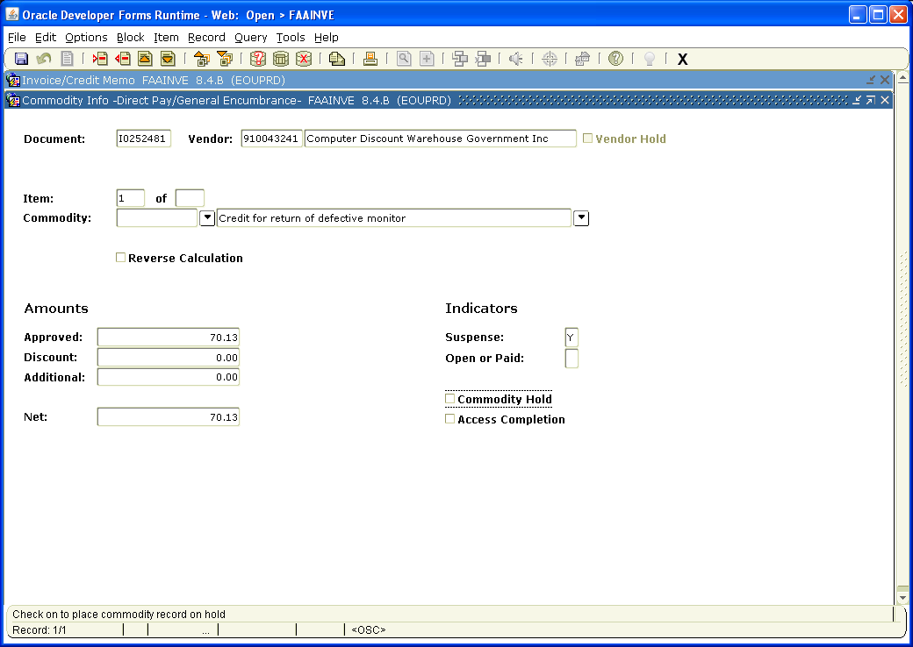

Tab over once. Enter description of purchase. Note: even if there are several items, they must fit in this field, (i.e. Paper, envelopes and pens, could be entered as stationary supplies).

Tab to Approved Amounts and enter the Amount Due (less any shipping) from the vendor’s invoice.

Tab to Additional Amounts and enter shipping charges from the vendor’s invoice.

Net Amounts should equal to the Total Amount Due on the vendor’s invoice.

NOTE: Even though this is a credit memo, the Approved and Net Amounts show as positive numbers.

Page down

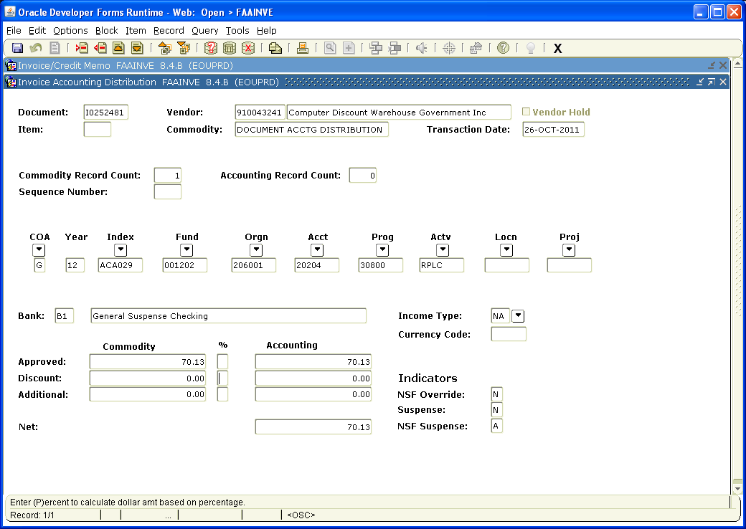

Enter Accounting Information (i.e. Index, Acct, Actv, etc).

Tab to Approved Accounting and enter amount to be charged to the Index/Acct.

Tab to Additional Accounting and add shipping if applicable. Net Accounting should reflect the total amount due on the vendor’s invoice.

NOTE: Again, even though this is a credit memo, the Approved and Net Amounts show as positive numbers.

Page down

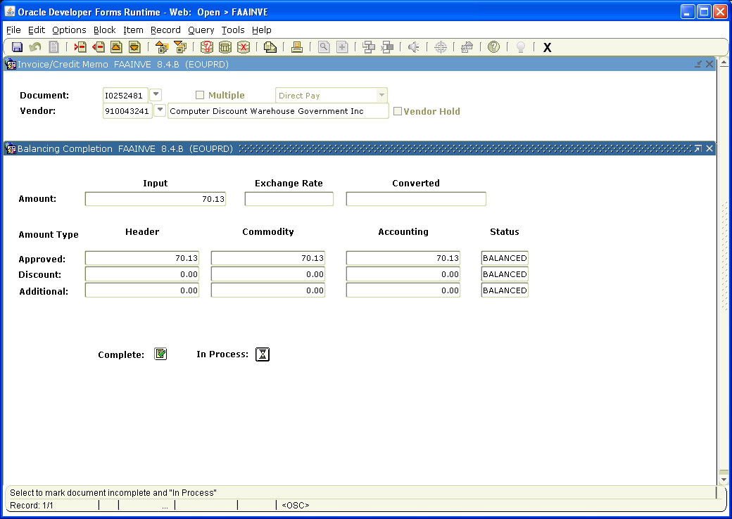

Click the box next to Complete to forward the invoice to Accounts Payable or In Process to save the document so you can work on it later.

After invoice is completed, please notify the Budget Authority that they need to approve it.

Be sure to send the credit memo originals to the Accounts Payable Office and keep a copy for your records.

