FAAINVE -- Direct Pay
To pay an invoice not paid against a Purchase Order

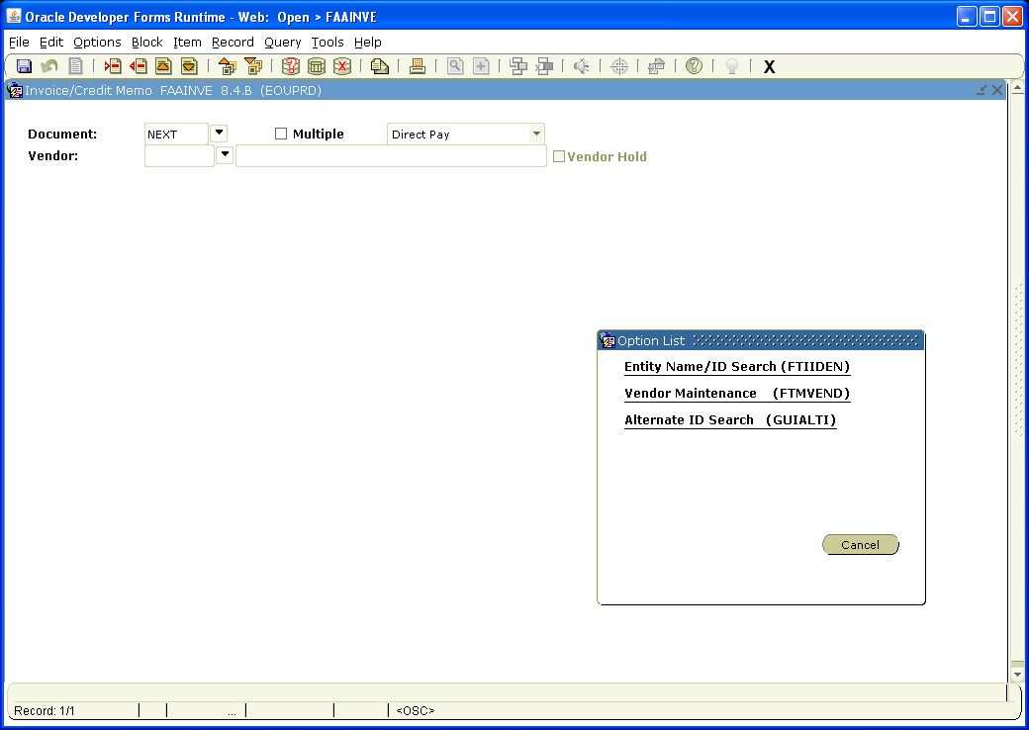
Query for Vendor ID #
Specify whether it is a Direct Pay or being paid against a PO

Type NEXT in Document field

If you don’t know the vendor code, click on the down arrow by vendor and click on Entity Name/ID search.

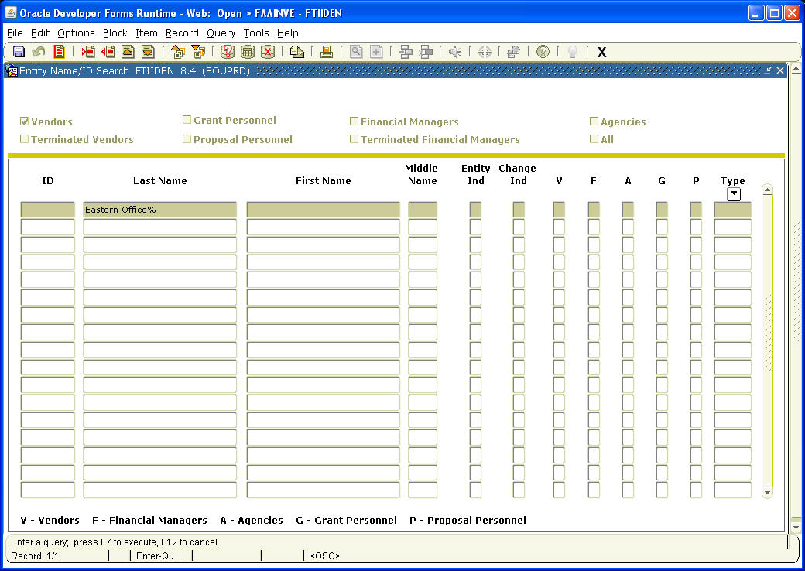

Click on ? on the toolbar to Enter Query

Type name of the vendor in the last name field. Fields are case sensitive, use % as wild card at the end of the vendor name.

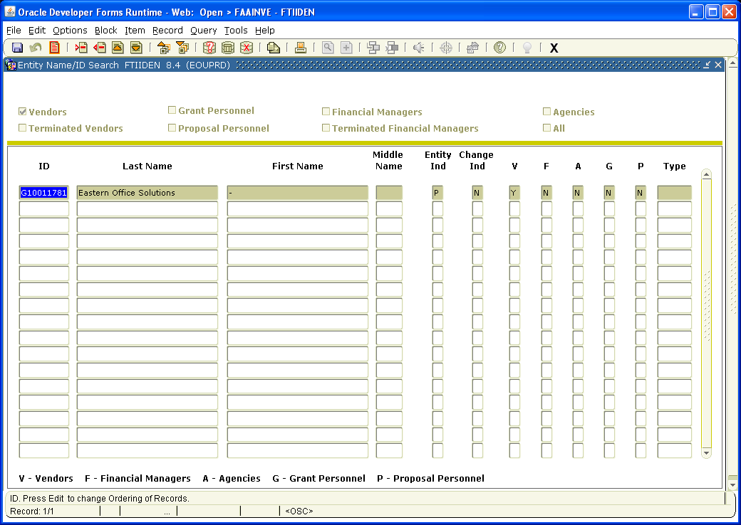

Click on button to the right of the ? on the toolbar to Execute the Query

Once the vendor ID is highlighted hit select on the tool bar.

If you cannot locate the correct vendor, try other variations of the name, (i.e. BiMart instead of BI MART). If you still cannot locate the vendor, contact Accounts Payable Office for assistance.

Page Down

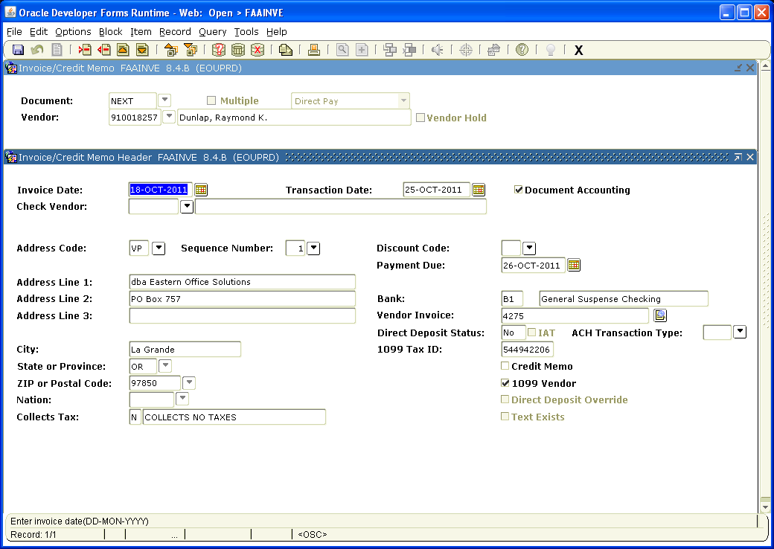
Exact invoice number from vendor invoice
Exact remit address from vendor invoice
Backdate if necessary
Type date off Vendor Invoice
Type in the date of the invoice from the vendor’s invoice in the Invoice Date field.

Tab to Transaction Date and enter the transaction date – usually “today” unless you are backdating to have expense moved to prior month. If that is the case, date it to the last day of that month.

Verify that the Address matches the Remit To: address on the vendor’s invoice. If it does not, Click on the arrow next to the Sequence Number and select the correct address. If the correct address is not available contact Accounts Payable and they will help you get it added.

Tab to Payment Due field and enter the Due Date. Note: Checks are cut every Wednesday – the Payment Due date is the date that the check will be cut and mailed, so ideally, you should enter a date that falls on a Wednesday at least 7 days prior to the due date shown on the vendor’s invoice. That will allow a week for the check to be mailed and received after it is cut. If no due date is shown on the vendor’s invoice, use the date of the next Wednesday. If the address field has *****DIRECT DEPOSIT ONLY***** key it to that address no matter the address in the field. Accounts Payable does direct deposit every day, so you can enter the next day’s date as the Payment Due.

Tab to Vendor Invoice field. Enter the vendor’s invoice number exactly as it appears on the vendor’s invoice. If no invoice # is shown, enter the account number and invoice date. If paying for services from Eastern Office Solutions, put the PSA # first, then dash, then invoice number. Example= PSA# 112163-4545

Page down
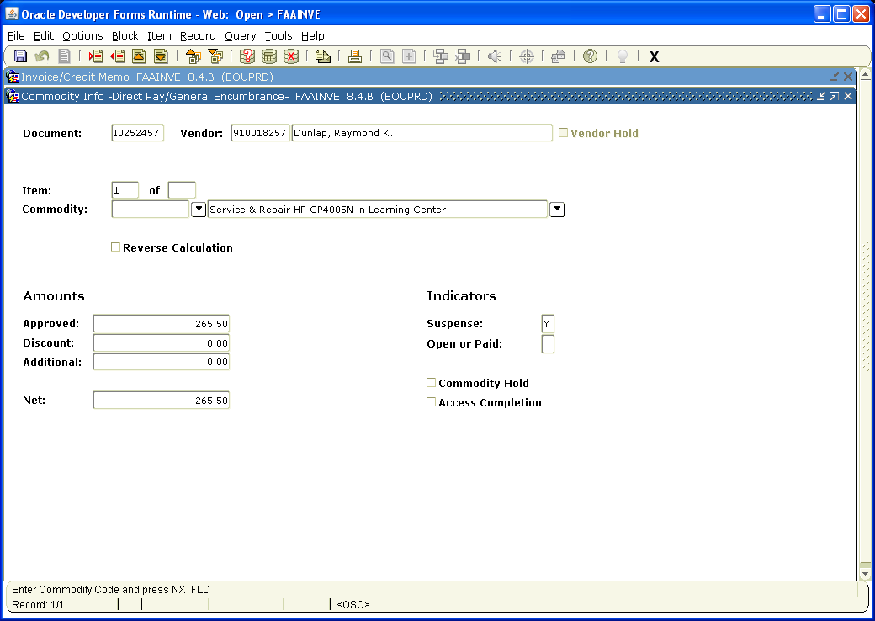
Shipping Costs if applicable
Entire amount of invoice - shipping
Enter description of purchase, so A/P knows what you are paying for

Tab over once. Enter description of purchase. Note: even if there are several items, they must fit in this field, (i.e. Paper, envelopes and pens, could be entered as stationary supplies).

Tab to Approved Amounts and enter the Amount Due from the vendor’s invoice.

Tab to Additional Amounts and enter shipping charges from the vendor’s invoice.

Net Amounts should equal to the Total Amount Due on the vendor’s invoice.

Page down

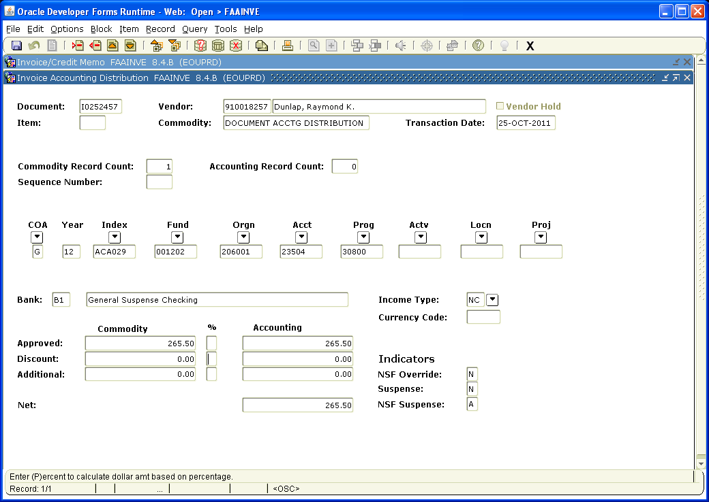

Enter Accounting Information (i.e. Index, Acct, Actv, etc).

Tab to Approved Accounting and enter amount to be charged to the Index/Acct.

Tab to Additional Accounting and add shipping if applicable. Net Accounting should reflect the total amount due on the vendor’s invoice.

From here, write down the Document number, the account code and the index on the invoice.

Also note, if billing to more than one account index for the same invoice arrow down on this page and repeat the process of entering the accounting information for the additional account. Make sure that the total of the two charges matches the overall total for the invoice.

Page down

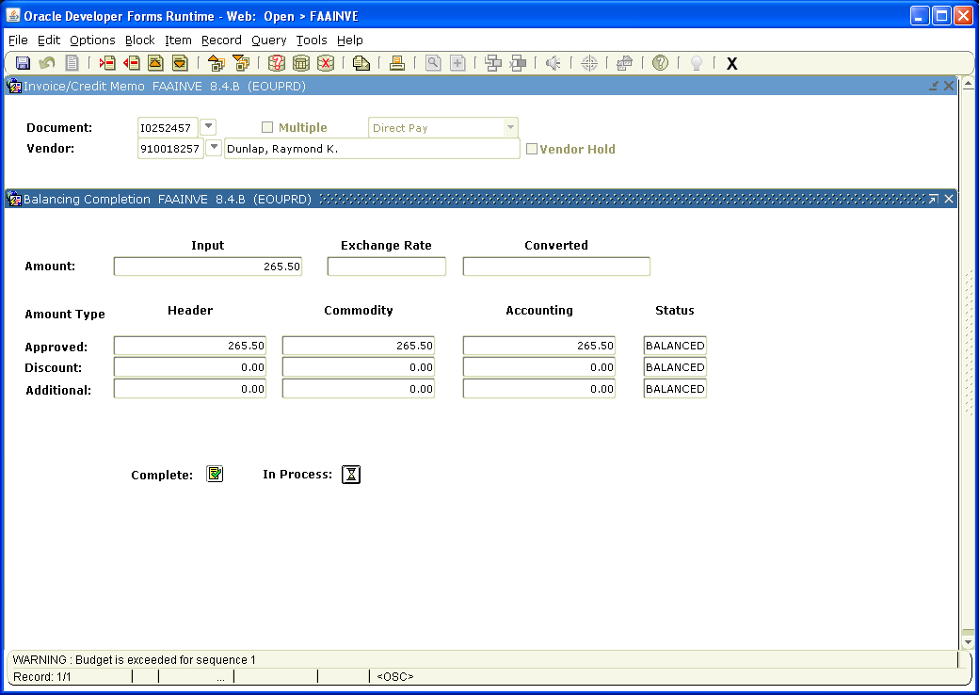

Click the box next to Complete to forward the invoice to Accounts Payable or In Process to save the invoice so you can work on it later.

After invoice is completed, please notify the Budget Authority that they need to approve it.

Be sure to send the original invoice to the Accounts Payable Office and keep a copy for your records.

