

Procurement
Card
Module

Eastern Oregon University
2012

Table of Contents

Step-by-Step Process 3
Banner Messages 4
FAAINVT Instructions 5
Email Notifications 8
New Transactions 8
Reminder Messages 9
Overdue Transactions 10
Completed Transactions 11
Important Definitions 12
Backdating 12
Banner Reports 13
FWRRCON – Reconciliation Report 13
FWRUDST - Undistributed Transactions Report 14
FWRPLOG – Procurement Card Purchasing Log 14
Deadlines 16
Daily 16
Bi-Weekly 16
Monthly 17
Appendix A……………………………………………………………………………….18
Appendix B……………………………………………………………………………….19
Appendix C……………………………………………………………………………….20
Appendix D……………………………………………………………………………….21
Appendix E……………………………………………………………………………….22

Step-by-Step Process

- Purchase is made at a vendor
- The charge is processed through the bank the night after the transaction is made
- The morning after the transaction is processed, the custodian receives a new transactions email
- The custodian changes the account code and adds a description in FAAINVT
- That night, a process runs and the charge posts in Banner as an expense
- A completed transactions email is sent to the custodian the next morning
- Custodian prints the completed transactions email and attaches receipt(s)
- Custodian sends a weekly packet (containing receipts and emails) to AP on Mondays




Charge posts to EOU bank account
Purchase is made at the vendor
(night of the purchase)
*Because of weekends and holidays, it could take 1 or 2 days from the date of purchase, for the charge to process through the bank.
FAAINVT
Custodian will change the account code and add a description to the transaction in FAAINVT
(day of the notification email)
Print out this email and attach to your corresponding receipts. Send to the Accounts Payable office in your weekly packet.

GENERAL LEDGER
Transactions are loaded in Banner
(2nd day after the purchase)
New transactions email is sent
(2nd day after the purchase)
(night after changes are made)
Transactions post to the proper index as expenses
Completed transactions email is sent
(night after changes are made)

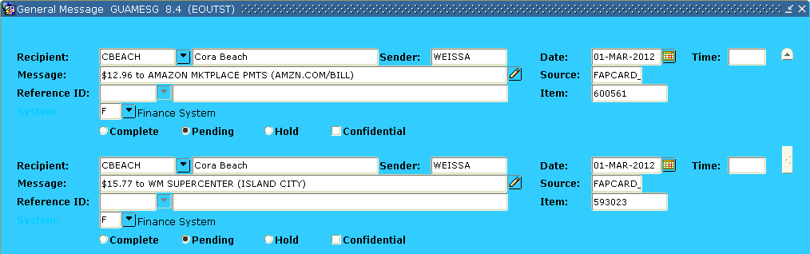
Banner Messages

When a new transaction is loaded into Banner from the bank, you will receive a Banner message with the details. The information will be very similar to that on the “New Transactions” email that you receive.

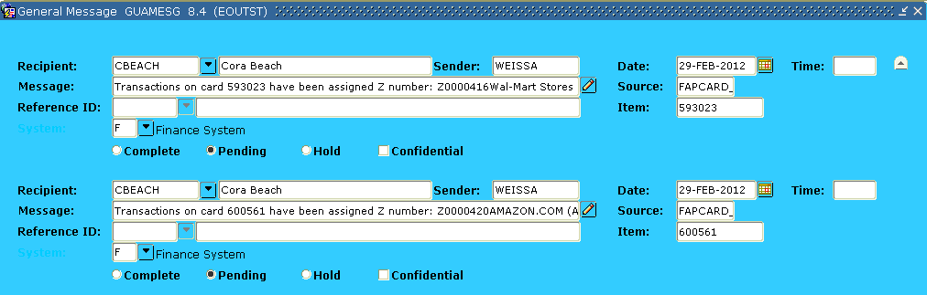
When you have changed the account code and added a commodity description to a transaction in FAAINVT, that transaction will feed through to the finance ledgers and generate a “Z” document number in Banner. You will receive a Banner message the next day with a “Z” document number that was generated for the transaction.

The information in these messages will be very similar to that on the “Completed Transactions” email that you receive.

The “Z” number is considered a document number in Banner. You will be able to see this number in vendor history if that specific vendor is already in our system.

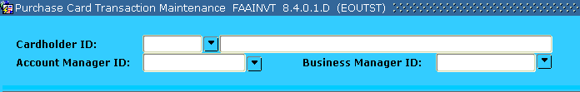
FAAINVT Instructions

TAB (3 times) to the Account Manager ID box and enter the initial of your first name followed by the first 7 letters of your last name (your Banner username) OR click the arrow on the right and query to find your name

After entering your name, hit PAGE DOWN (do NOT arrow down) to enter the next block

The next block in this form will show you all of your cards that have charges waiting to be reclassed. You can scroll through the different cards by using arrow up and arrow down (not page up/page down)

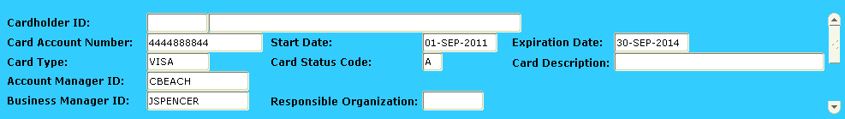
Your Banner username will default in the Account Manager ID field

The full name of the Unit Administrator and their banner ID will show up in the Cardholder ID field. The last 6 digits of your credit card number will also be visible in the Card Account Number field (preceded by 4444888844). Also, make sure the card description box contains the correct department information

When you find the correct card as identified on your notification email, PAGE DOWN once to the third block

This third block shows all the unfed (not fed) transactions for the card selected in the second block (see print screen on next page)

If you would like to see the FED transactions, select Fed Transactions in the drop down menu while you are in the first block

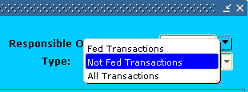
If you would like to see ALL the transactions, select All Transactions in the drop down menu while you are in the first block

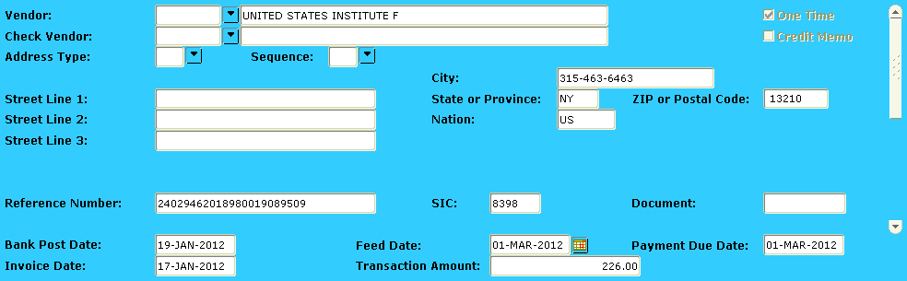
Find the transaction that needs to be reclassed by using the arrow keys while in this block. Look at the vendor name, transaction amount, and invoice date to identify the correct charge. The invoice date should match the date printed on the receipt

(SEE INFORMATION FOR BACKDATING ON PAGE 12)

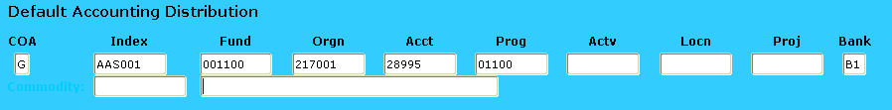
When you find the correct charge, hit PAGE DOWN once (do NOT arrow down)

This next screen is where you will add a detailed commodity description and change the account code from 28995

TAB once and then enter a detailed description of what was purchased in the Commodity field

Once your commodity is entered, hit PAGE DOWN once

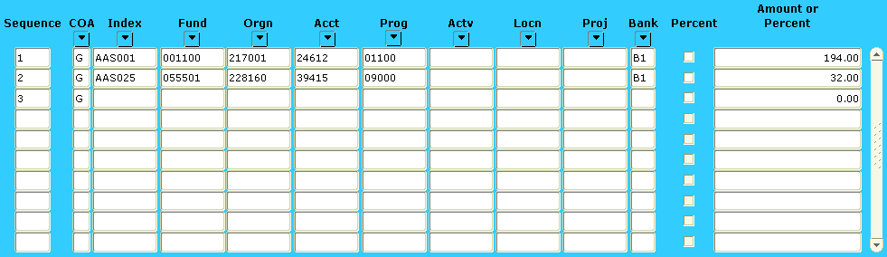
This block is where you can split up a transaction into different account codes, indexes, amounts…etc

TAB to the Index field and change the default index (if necessary) to the one you want to use

TAB over to the Acct field and change 28995 to the proper account code for what was purchased

TAB to the Actv field and enter an activity code if necessary

If you need to use more than one index, account code, or activity code, you can change the number in the Amount or Percent field to be any amount

In order to complete the process, the total amount of all sequences in this block should equal the total dollar amount in the Transaction Amount field at the top of this screen

To add another index, account code, or activity code, ARROW DOWN and a second sequence will be created

Enter the index, account code, activity code (if necessary) and the correct amount in the next sequence that was created

You may also enter percentages in the Amount or Percent field if you do not know the exact dollar amount. Banner will calculate the percentages.

Repeat steps 18 and 19 as needed

If you create an extra sequence line that is not needed hold SHIFT + F6 to delete that sequence line

Hit SAVE (F10) when the reclass is completed, then you can EXIT (F12)

When the automatic nightly process runs, all records with accounts codes other than 28995 will be fed to finance ledgers and should be reflected as an expense in your budget the following day

Email Notifications

***IF YOU ARE SUPPOSED TO RECEIVE MULTIPLE EMAIL NOTIFICATIONS ON THE SAME DAY, THEY WILL ALL BE COMBINED IN ONE EMAIL***

New Transactions

The custodian will receive a “New Transactions” email when a purchase is made with the procurement card. The custodian will receive these emails every morning, unless there were no transactions processed through the bank the night before.

This email below is the first notification you will get regarding your new p-card charges.

Please follow the FAAINVT instructions to reclass all the transactions that show up on the “New Transactions” email.

All of these transactions below are classified as NOT FED until the account codes are changed and they have commodity descriptions. Once this has happened, the transactions will be FED through Banner and reflected in your fund as expenses.

cbeach@eou.edu
PCARD Messages for CBEACH [14-FEB-12 through 14-FEB-12]

---------------------------------
New Transactions:
---------------------------------
This is to notify you that you have new procurement card transactions. Please use the Banner form FAAINVT (Purchase Card Transaction Maintenance) to distribute these transactions to the appropriate account codes. If you have questions please contact your Procurement Card Administrator.

585847 - $1,444.99 to GCI*MUSICIAN'S FRIEND (800-776-5173)

585847 - $12.97 to AMAZON MKTPLACE PMTS (AMZN.COM/BILL)

585847 - $120.95 to MYGIRLDRESS.COM (2132370009)

585847 - $226.00 to UNITED STATES INSTITUTE F (315-463-6463)

585847 - $25.98 to AMAZON MKTPLACE PMTS (AMZN.COM/BILL)

Transaction amount and vendor name
Last 6 digits of p-card number

Reminder Messages

The Custodian and the Procurement Card Program Administrator (Jolynne Spencer) will receive a “Reminder Message” 7 days after the “New Transactions” email is sent, if there are still transactions out there that have not been fed. Both will continue to receive these reminder emails every 7 days until the transactions are fed through to the finance system.

This email will be the second email sent regarding your p-card transactions that still need to be reclassed in Banner.

When you receive these reminder emails, please go out to FAAINVT and reclass all the transactions identified on the email.

All of these transactions below are classified as NOT FED until the account codes are changed and they have commodity descriptions. Once this has happened, the transactions will be FED through Banner and reflected in your fund as expenses.

cbeach@eou.edu
PCARD Messages for CBEACH [28-FEB-12 through 28-FEB-12]

---------------------------------
Reminder Messages:
---------------------------------
This is to notify you that you have procurement card transactions that have not been distributed. Please complete these by the end of the month to have them included in the current period

585847 - $12.97 to AMAZON MKTPLACE PMTS (AMZN.COM/BILL)

585847 - $120.95 to MYGIRLDRESS.COM (2132370009)

585847 - $226.00 to UNITED STATES INSTITUTE F (315-463-6463)

585847 - $25.98 to AMAZON MKTPLACE PMTS (AMZN.COM/BILL)

585847 - $250.00 to LYNDA.COM (805-477-3900)

Overdue Transactions

This email below is the “Overdue Transactions” email. For example, if you have charges on the February statement, an email will be sent to the Custodian and Budget Authority in March. This email will list all the transactions from the February statement that have not been FED.

This overdue email is URGENT. These charges will most likely need to be backdated.

When you receive these reminder emails, please go out to FAAINVT and reclass all the transactions identified on the email.

All of these transactions below are classified as NOT FED until the account codes are changed and they have commodity descriptions. Once this has happened, the transactions will be FED through Banner and reflected in your fund as expenses.

cbeach@eou.edu
PCARD Messages for CBEACH [01-MAR-12 through 01-MAR-12]

---------------------------------
Overdue Transactions:
---------------------------------
This is a reminder that you have procurement card charges in Banner FAAINVT's (Purchase Card Transaction Maintenance) form that have not yet been distributed to the appropriate account codes. If you have questions regarding how to distribute these charges, please contact your Procurement Card Administrator.

585847 - $12.97 to AMAZON MKTPLACE PMTS (AMZN.COM/BILL)

585847 - $120.95 to MYGIRLDRESS.COM (2132370009)

585847 - $226.00 to UNITED STATES INSTITUTE F (315-463-6463)

585847 - $25.98 to AMAZON MKTPLACE PMTS (AMZN.COM/BILL)

585847 - $250.00 to LYNDA.COM (805-477-3900)

Completed Transactions

After the account code is changed from 28995 and there is a commodity description for the p-card transactions, the custodian will receive a “Completed Transactions” email.

This will be the last email you receive in regards to these specific transactions.

Print this email and attach it to the corresponding receipts along with appropriate documentation.

This email will show all the transactions that have been posted as expenses in Banner. This email will also show you the “Z” number that has been generated for each transaction. All these transactions below are now classified as FED in Banner and will show up as expenses in your budget.

cbeach@eou.edu
PCARD Messages for CBEACH [29-FEB-12 through 29-FEB-12]

---------------------------------
Completed Transactions:
---------------------------------
The following transactions have fed into the Banner system and have been assigned an Z number. The Z number is listed for your convenience. Please record it on your log for future reference.

592975 - Transactions on card 592975 have been assigned Z number: Z0000415
AMERICAN INSTITUTE AVA (970-2090486) - $126.00

593023 - Transactions on card 593023 have been assigned Z number: Z0000416
Wal-Mart Stores LLC (ISLAND CITY) - $7.34

593023 - Transactions on card 593023 have been assigned Z number: Z0000417
Wal-Mart Stores LLC (ISLAND CITY) - $12.67

593023 - Transactions on card 593023 have been assigned Z number: Z0000418
Starbucks Corporation (LA GRANDE) - $12.95

593023 - Transactions on card 593023 have been assigned Z number: Z0000419
Wal-Mart Stores LLC (ISLAND CITY) - $17.64

This number will show up as a document number in vendor history. It will also show up in FAAINVT under FED transactions.

Important Definitions

Banner Transaction Date – The date a transaction is fed into Banner and posts to the finance ledger as an expense (same as the Feed Date)

Post Date (Bank Post Date) – The date the transaction posts at the bank

Bank Transaction Date (Purchase Date or Invoice Date) – The date the purchase was actually made. The actual date on the credit card receipt (this should be the same as the date shown on the statement)

Feed Date – The date the transaction will feed to the Banner finance ledgers as an expense (this will only happen if the transaction has a commodity description and the account code is NOT 28995)

Billing Period – The billing period will start on the 26th and end on the 25th of the next month. Due to weekends and holidays, these dates are not always the same. You can view the actual statement dates in the Banner screen FTMPCSH

Account Manager – Card Custodian

Business Manager – Procurement Card Program Administrator

Cardholder – Unit Administrator/Budget Authority

Backdating

The period for backdating will be during the first 3 business days of every month. Every transaction that took place in the previous month will have to be backdated after the new month begins.

How To: The custodian will change the Feed Date in FAAINVT to the last day of the previous month. The Feed Date is similar to the Transaction Date used for invoices and journal vouchers. After step #8 and before step #9 in the FAAINVT Instructions, you will tab over to the Feed Date field. Then, change this date to the last day of the previous month and move on to step #9.

For example: If it is the first or second of May, and the transaction is from April, you will change the Feed Date to 31-APR-2012.

Banner Reports

FWRRCON – Reconciliation Report

This report will show both the FED and UNFED transactions on a particular card. You can use this report to see what transactions you have already reclassed, and what transactions still need to be reclassed. The column on the left is labeled “Status”. The transactions that have Fed in this column have already been fed to the finance system. This means, you have changed the account code and added a commodity description, these transactions should also have a “Z” number assigned to them. The transactions that have Unfed in that status column still need to be reclassed.

This report can also be helpful when compared with your monthly bank statement. If you print out this report for the statement period, the total amount of transactions on this report should be equal to the balance shown on your statement??

Report Printing Instructions

Type FWRRCON in the “Go To…” box on your main Banner screen

You also can navigate to screen GJAPCTL, then type in FWRRCON

This will take you to the report screen in Banner, FWRRCON (PCard Reconciliation Report) should default in the Process box at the top.

PAGE DOWN once, then enter the printer that you want your report to print on. (usually in the form of EO_PRINT##)

PAGE DOWN once, TAB once, and enter the parameters.

In the from “bank post date” field – enter the day you want your report to start on. For example, the start of the statement period might be 26-FEB-2012 (use this format when entering a date)

ARROW DOWN, in the to“bank post date” field – enter the last day you want your report to end on. Please see the IMPORTANT DATES section of this manual to explain the bank post date.

If you are running this report for a statement period, ideally the start date should be the 26th and the end date should be the 25th of the next month (keep in mind, these are not always the statement start and end dates due to weekends and holidays).

ARROW DOWN, in the card number field, enter the LAST 6 DIGITS of the credit card that you want to print a report for.

PAGE DOWN once

Do NOT put a checkmark in the “Save Parameter Set As” field

Just click SAVE at the top of the screen (or hit F10).

SEE APPENDIX A for an example of an FWRRCON report

FWRUDST - Undistributed Transactions Report

This report can be run at any time. This will give the custodian a list of transactions that are still NOT FED through to the finance system. Any transactions that show up on this report need to be reclassed. You need to go into FAAINVT, add a commodity description and change the account code from 28995 for EVERY transaction on that undistributed list.

Report Printing Instructions

Type FWRUDST in the “Go To…” box on your main Banner screen

You also can navigate to screen GJAPCTL, then type in FWRUDST

This will take you to the report screen in Banner, FWRUDST (PCard Undistributed Trans Rpt) should default in the Process box at the top.

PAGE DOWN once, then enter the printer that you want your report to print on. (usually in the form EO_PRINT##)

PAGE DOWN once, TAB once, and enter the parameters.

This report only requires an entry in the card number field, enter the LAST 6 DIGITS of the credit card that you want to print a report for.

PAGE DOWN once

Do NOT put a checkmark in the “Save Parameter Set As” field

Just click SAVE at the top of the screen (or hit F10).

SEE APPENDIX C for an example of an FWRUDST report

FWRPLOG – Procurement Card Purchasing Log

This report has essentially the same information as your hand written activity log. Do NOT use this report in place of your hand written log. This report should be used at the end of a bank statement period to double check transaction information.

All custodians must continue to keep a hand written activity log. This hand written activity log should include the following…

Name of person using the card

Name of person requesting payment (if different from the card user)

Date of transaction

Amount of transaction

Vendor name

Account code

Index

Description

All the items above should be recorded on the activity log at the time of purchase. If the card is taken off campus, the name of the user should be recorded on the log when the card is checked out. Then, the rest of the transaction information should be written on the log immediately after the card is returned.

If the custodian keeps a very detailed activity log, the daily reclassification of transactions in FAAINVT will be much easier and less time consuming.

Report Printing Instructions

Type FWRPLOG in the “Go To…” box on your main Banner screen

You also can navigate to screen GJAPCTL, then type in FWRPLOG

This will take you to the report screen in Banner, FWRPLOG (Procurement Card Purchasing Log) should default in the Process box at the top.

PAGE DOWN once, then enter the printer that you want your report to print on. (usually in the form of EO_PRINT##)

PAGE DOWN once, TAB once, and enter the parameters.

In the credit card number field, enter the LAST 6 DIGITS of the credit card that you want to print the log for.

ARROW DOWN, in the from feed date field – enter the day you want your report to start on. Please see the IMPORTANT DATES section of this manual to explain the feed date.

ARROW DOWN, in the to feed date field – enter the day you want your report to end on.

ARROW DOWN, in the card number field, enter the LAST 6 DIGITS of the credit card that you want to print a report for.

PAGE DOWN once

Do NOT put a checkmark in the “Save Parameter Set As” field

Just click SAVE at the top of the screen (or hit F10).

Printing the Monthly Banner Activity Log

Follow the Report Printing Instructions using these parameters below for the “Feed Date”.

In the From Feed Date field, please enter the first day of your U.S. Bank billing period (the date of the first transaction on your statement).

In the To Feed Date field, please enter 2 days after the last day of your billing period (2 days after the date of the last transaction on your statement).

SEE APPENDIX B for an example of an FWRPLOG report

SEE APPENDIX D for an example of a written activity log

Deadlines

Daily

You should be doing the reclass in FAAINVT every day that you receive a New Transactions email. If you are out of the office, please try to reclass your charges so they feed as soon as you can get to them. Please do not wait until the end of the month to change the transaction information in FAAINVT. We want your budgets to reflect your credit card expenses as soon as possible.

Before changing the account code from 28995, you must have the physical itemized receipt for each purchase. Break up the account codes based on the items listed on the receipt. Also, add a very detailed commodity description (be sure to add document text if you run out of room in the commodity description, it is VERY important that you describe all the items purchased AND their purpose)

Bi-Weekly

Every second Tuesday of the month please send your packet of receipts and completed transaction emails from the two weeks prior over to the Accounts Payable office (Inlow Hall 208).

Every other MONDAY you will compile your receipts and completed emails from the last two weeks into a packet.

Complete the Bi-Weekly Procurement Card Packet Form in FULL and staple in front of your receipts and emails form the past two weeks. (this form can be found on the Accounts Payable website)

Sign and date this bi-weekly form as the Custodian when all appropriate documents are attached.

Have the Budget Authority review the packet with all proper documentation, then have them sign and date the bi-weekly form in the space provided.

You must make a copy of the signed Bi-Weekly Procurement Card Packet Form to keep in your office before sending your packet to Accounts Payable.

This packet is DUE in the Accounts Payable office every other Tuesday by 5:00pm.

Required information in your bi-weekly packet…

Completed and signed bi-weekly procurement card packet form (See appendix E)

Completed Transactions emails from the last two weeks

Itemized receipts for your completed transactions

Make sure the emails have your “Z” number that was generated for each fed transaction.

SEE APPENDIX E for an example of the bi-weekly procurement card packet form

Monthly

You will still receive a U.S. Bank procurement card statement at the beginning of every month.

Follow these steps after you receive your monthly statement…

Review your statement and check off ALL of the transactions, whose receipts have been sent over to the Accounts Payable office.

Attach the completed transaction emails and receipts for the remaining charges on the statement that have not already been sent to the AP office.

Print out your monthly Banner activity log. See the printing the monthly activity Banner log box under FWRPLOG in the Reports section of this manual.

There may be some transactions close to the beginning or end of the statement period that show up on your Banner activity log, but are not on your U.S. Bank statement. Please cross these transactions out on your Banner activity log.

Look at the fourth column on your Banner activity log. There should be a “Z” number generated for every transaction on your statement. If there is a charge on your log without a “Z” number, go into FAAINVT and reclass that transaction.

You will have to wait one day for that transaction to feed. Then, repeat steps 3 through 5 the following day.

Once your Banner log agrees with your statement, please sign and date the Banner log as the custodian in the space provided.

Attach the Banner log, U.S. Bank statement, and remaining receipts and emails in a packet to send to the Accounts Payable office.

Have the budget authority review the statement with all proper documentation, then have them sign and date the Banner log in the space provided.

You must make a copy of your FWRPLOG and the US Bank Statement to keep in your office before sending your packet to Accounts Payable.

Send this packet over to the Accounts Payable office before the deadline identified in the monthly **End of Period Deadlines & Office Max** email.

